***DAY 3 ASSIGNMENT***

* ***A file named myfile in “vi” editor:***

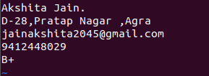

* ***Displaying myfile using cat command:***

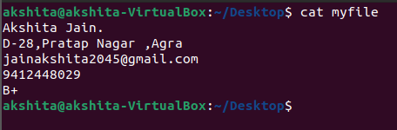

* ***Display the content in one line:***

